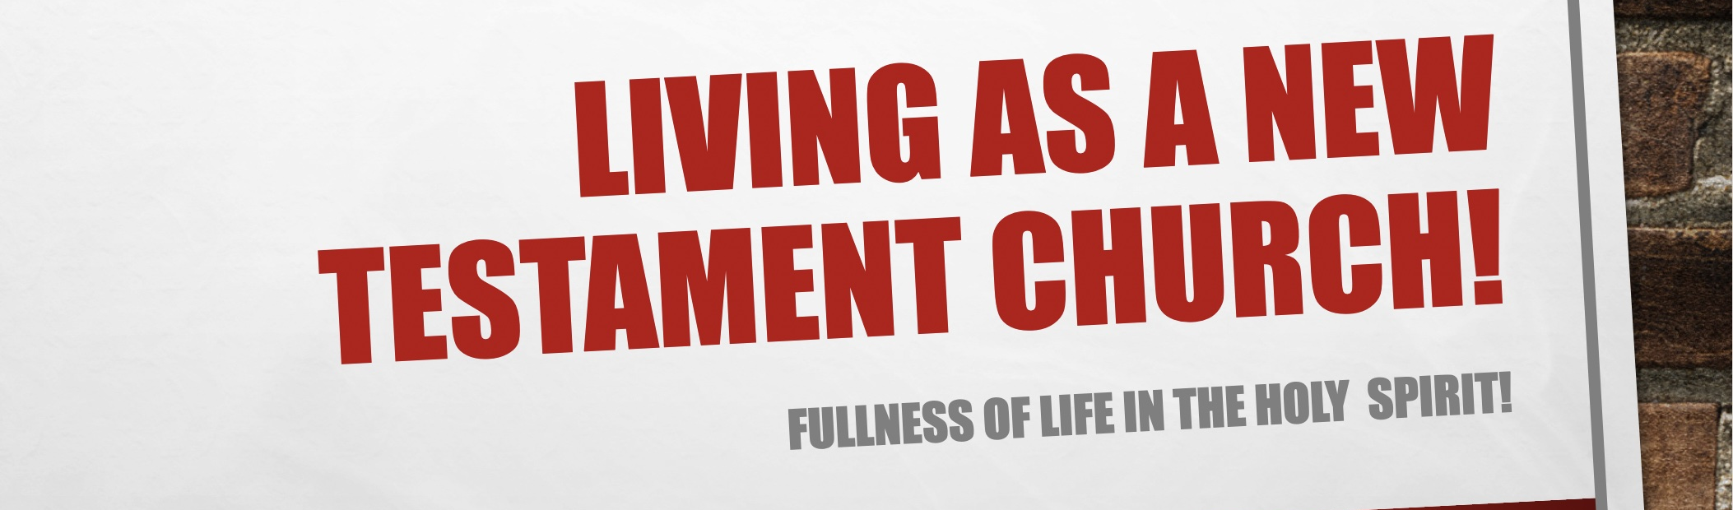

GROUP HINTS
- WORSHIP: Deliberately choose songs (if you’re singing/listening – there are other ways to do worship!) that are ABOUT GOD, and WHO HE IS. You may want to use the song sung on Sunday if they are helpful.
- COMMUNION: Communion is always a great and an opportunity to help people grow in leading this ‘section’
- WORD: Start by reading these scriptures and getting everyone to STOP and BE STILL, and think about God as the verses are read (closing eyes might help). Encourage everyone to ‘gather their scattered senses’ to think on God.

KEY QUESTIONS

- Can you give an example of how repentance plays a part in your daily living since you came to faith?

- Why do you think some people delay getting baptised in water by full immersion?

- Have you been baptised in the Holy Spirit? Share some testimonies and offer prayer for anyone who would like to be baptised in the Holy Spirit or indeed receive a fresh touch of the Holy Spirit.

Questions from Wilkin, Jen. None Like Him (p. 29). Crossway. Kindle Edition.

