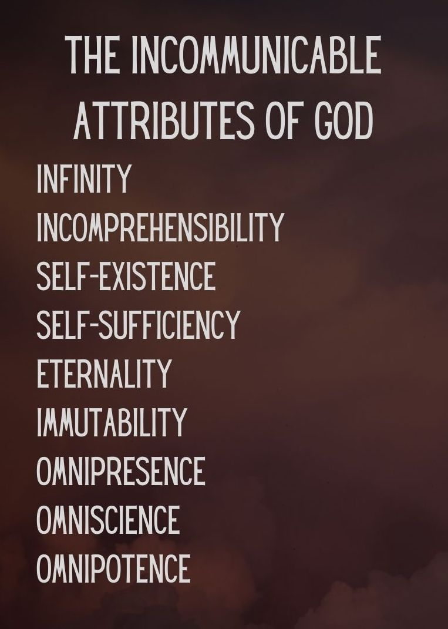
Key Truth/Principle
‘What comes into our minds when we think about God is the most important thing about us.. Were we to extract from any man a complete answer to the question, 'What comes into your mind when you think about God?' we might predict with certainty the spiritual future of that man (AW Tozer)

Key Verse(s)
Psalm 139

Key Point(s)
- God is Omnipresent

GROUP HINTS
- WORSHIP: Deliberately choose songs (if you’re singing/listening – there are other ways to do worship!) that are ABOUT GOD, and WHO HE IS. You may want to use the song sung on Sunday if they are helpful.
- COMMUNION: Communion would be a great way to finish things (or during) as it focuses us on the WEIGHT & WONDER of God! Hebrews 12 can be a great weekly passage to dip into
- WORD: Start by reading these scriptures and getting everyone to STOP and BE STILL, and think about God as the verses are read (closing eyes might help). Encourage everyone to ‘gather their scattered senses’ to think on God.

KEY QUESTIONS

- Are you living with a daily awareness that God is present in every part of your life? In your thinking, in your speech, in your actions and in your inactions?
- How can you grow in this awareness?
  - E.g. Scriptures, songs, habits

- How are you responding to the awareness that God is with you and indeed living in you if you are a Christian?
- How does this impact you? Your identity, companionship, expectation?

- Pray for breakthroughs in receiving his comfort, growing in courage, living free of fear, growing in trust and walking in holiness.

