

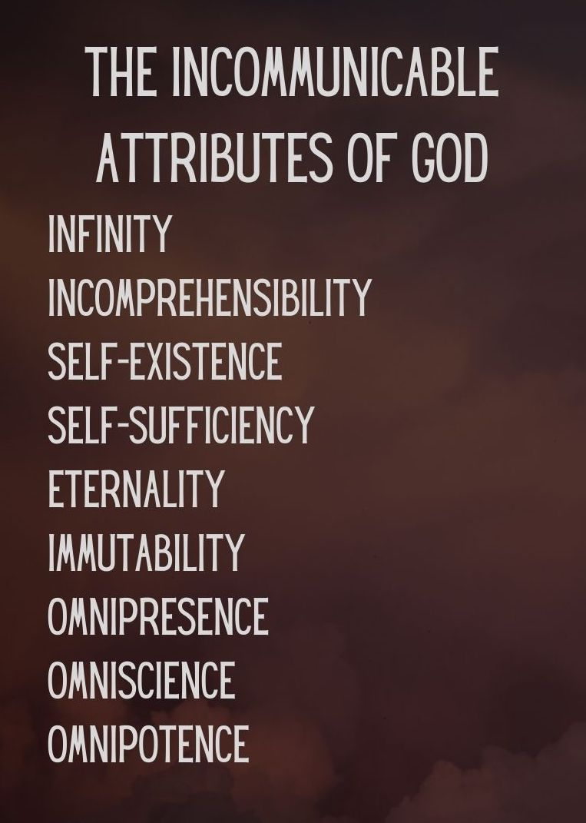

**Key Truth/Principle**

*‘What comes into our minds when we think about God is the most important thing about us..* *Were we to extract from any man a complete answer to the question, 'What comes into your mind when you think about God?' we might predict with certainty the spiritual future of that man (AW Tozer)*

**Key Verse(s)**

Psalm 47v1–2; 6–9 (NKJ); Matt 6v13 (NKJ); Matt 11v29 (NIV); Rev 19 v.6 (NKJ); Jer 32 v17–19

**Key Point(s)**

* God is Sovereign and Omnipotent

**GROUP HINTS**

* **WORSHIP:** Deliberately choose songs (if you’re singing/listening – there are other ways to do worship!) that are ABOUT GOD, and WHO HE IS. You may want to use the song sung on Sunday if they are helpful.
* **COMMUNION**: Communion would be a great way to finish things (or during) as it focuses us on the WEIGHT & WONDER of God! Hebrews 12 can be a great weekly passage to dip into
* **WORD:** Start by reading these scriptures and getting everyone to STOP and BE STILL, and think about God as the verses are read (closing eyes might help). Encourage everyone to ‘gather their scattered senses’ to think on God.

**KEY QUESTIONS**[1]

1. **What for you is one of the most amazing acts of God’s power in the Bible or in church history?**
2. **Have you personally experienced first -hand, unmistakable evidence of God’s power in action? (e.g. a miracle or in some other way)**
   * Would you like to share about it with us, including how it impacted you or left you feeling (e.g. maybe overawed; puzzled; fearful; or excited)
3. **Have you been limiting God’s ability to intervene in a situation in your life or in the life of a family member or friend?**
   * As the Lord to forgive you for you doubts and unbelief and pray for the situation with fresh faith
   * **This question may lead quite naturally to pray for one another’s personal needs**
4. **What does it mean for you for the all-knowing, all-powerful God to be your King and not just your Saviour?**
   * How does this affect how you live?
   * Are there aspects of your life you find difficult to surrender fully to the Lord (e.g. use of your time; finances, etc)

1. **You may have heard it said that “God is the Almighty; not the all-matey”. How do you feel about this?**
   * Do you think that Christians and churches today are inclined to be too casual towards God?
   * In what ways can we show greater reverence in corporate worship? (e.g. to be: on time and expectant to meet with God; more participative (incl. spiritual gifts); more responsive (e.g. with physical postures) to God’s presence and to what He says to us in our meetings.
   * Do you think the honour and respect shown by Prince Charles to his mother – the queen – on public occasions, has anything to teach us re our corporate worship times?

1. **As (born-again) children of God, we are not just citizens and subjects of God’s kingdom, but royal princes and princesses. Our destiny is to be kings and priests – see Rev.5 v.10 NKJ.**
   * How does this make you feel? Ponder on this – we can hold our heads up – we’re royalty – wow!
   * **This could provide a lead into a time of worship and communion.**Jarrod Cooper’s song: ‘King of kings, majesty’ would make a great choice – “In royal robes I don’t deserve, I live to serve Your majesty”

1.