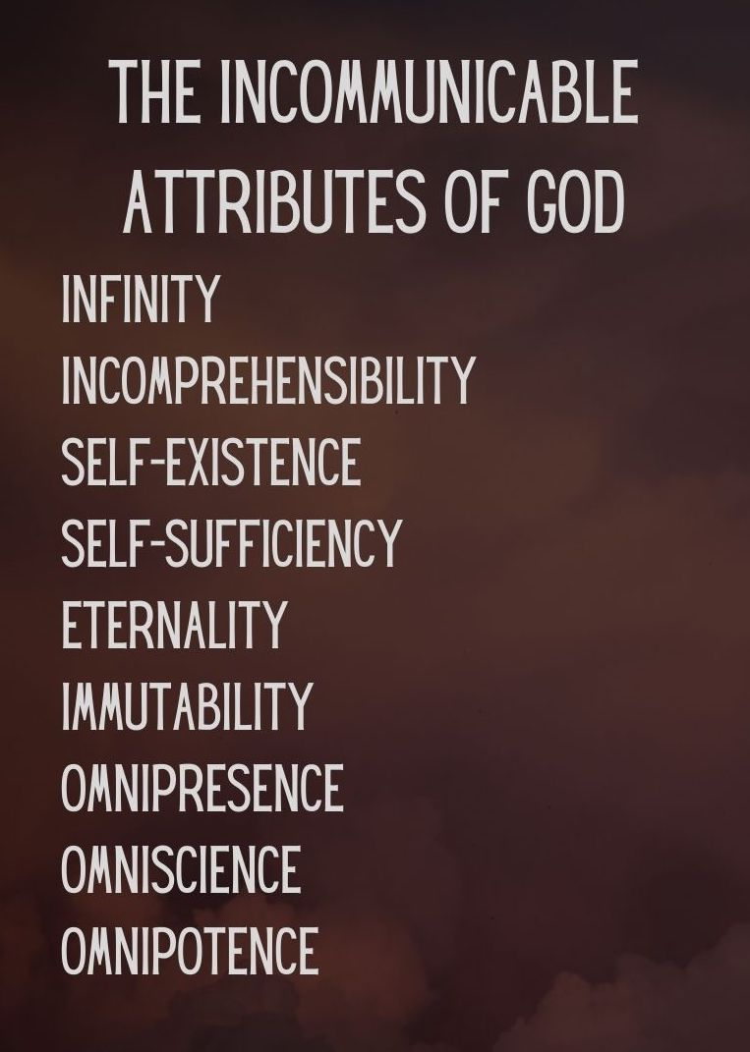
Key Truth/Principle
‘What comes into our minds when we think about God is the most important thing about us.. Were we to extract from any man a complete answer to the question, 'What comes into your mind when you think about God?' we might predict with certainty the spiritual future of that man (AW Tozer)

Key Verse(s)
Acts 17v22-25 / Ps 24v1-2 / Rev 4:11 / Ps 50:10-11 / Phil 4v19

Key Point(s)
- God is SELF SUFFICIENT & SELF EXISTING3

GROUP HINTS
- WORSHIP: Deliberately choose songs (if you’re singing/listening – there are other ways to do worship!) that are ABOUT GOD, and WHO HE IS. You may want to use the song sung on Sunday if they are helpful.
- COMMUNION: Communion would be a great way to finish things (or during) as it focuses us on the WEIGHT & WONDER of God! Hebrews 12 can be a great weekly passage to dip into
- WORD: Start by reading these scriptures and getting everyone to STOP and BE STILL, and think about God as the verses are read (closing eyes might help). Encourage everyone to ‘gather their scattered senses’ to think on God.

KEY QUESTIONS

- What struck you during the preach on Sunday?

- Geoff mentioned that we often use language like ‘I identify as…’ but because we (and the world around us) is constantly changing, the only secure identify is identifying as ‘He says we are’ because HE is unchanging.
  - What is your reaction to this?
  - In what ways do you struggle with your identity?

- God is self-sufficient – he does not need us!
  - How does that make you feel?
  - It releases us as we need to be obedient but not responsible for everything!
  - We sing the song ‘He didn’t want heaven with out us’ – how does his self-sufficiency affect how you think about that line?
    - Hint: expressing his love not need!
    - This can lead into a good discussion on thinking through song lyrics!

- How can you practically think about God more during your week?
  - Routine: Meal times, wake up, going to bed? (e.g. a verse when you wake up to fix your thoughts, kneeling when going to bed, prayer and pause at meal times)
  - Scripture memory: Weekly/situation al verses (e.g. at work if tough verses on God being sovereign. In suffering verses on trusting God..)
  - Group texts: scriptures/truths/reminders (possibly delegating each week to someone to stir thoughts, or a day to each member)

