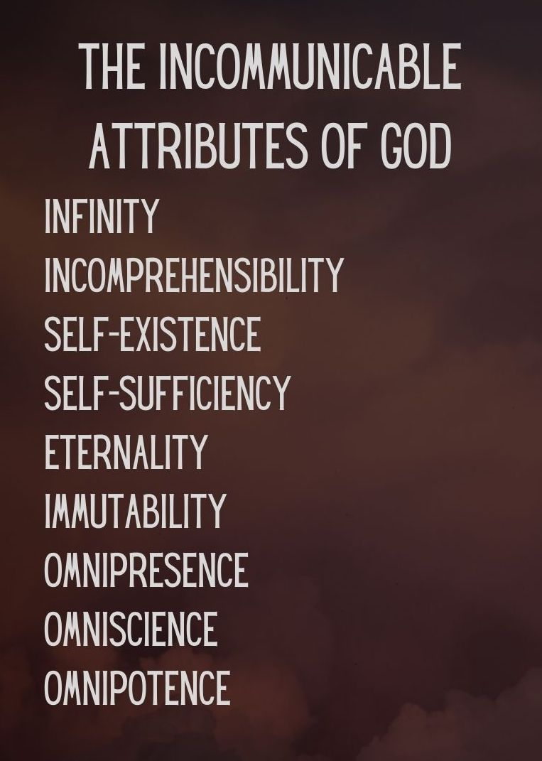
Key Truth/Principle
‘What comes into our minds when we think about God is the most important thing about us.. Were we to extract from any man a complete answer to the question, 'What comes into your mind when you think about God?' we might predict with certainty the spiritual future of that man (AW Tozer)

Key Verse(s)
Psalm 145:3 / Job 11:7-9 / John 1:14,18; 3:16 / Isa 55:6-9 / Rom 11:33-36

Key Point(s)
- God is INCOMPREHENSIBLE

GROUP HINTS
- WORSHIP: Deliberately choose songs (if you’re singing/listening – there are other ways to do worship!) that are ABOUT GOD, and WHO HE IS. You may want to use the song sung on Sunday if they are helpful.
- COMMUNION: Communion would be a great way to finish things (or during) as it focuses us on the WEIGHT & WONDER of God! Hebrews 12 can be a great weekly passage to dip into
- WORD: Start by reading these scriptures and getting everyone to STOP and BE STILL, and think about God as the verses are read (closing eyes might help). Encourage everyone to ‘gather their scattered senses’ to think on God.

KEY QUESTIONS

- How does the knowledge that God cannot be fully known make you feel?
  - List some positive feelings and some negative feelings. Explain your answers.

- List three statements that you know to be true about God. How did you learn them?

- Are there things you ‘know’ about God that cause more resistance than praise?
  - Why might that be?
  - Are those things true? (e.g. OT angry God actually displays God’s endless patience and mercy despite rebellion and sin. Isa 55)

- Think of a difficult person in your life. How well do you truly know him or her?
  - How might acknowledging your limited understanding change the way you interact with him or her?

- How can you practically think about God more during your week?
  - Routine: Meal times, wake up, going to bed? (e.g. a verse when you wake up to fix your thoughts, kneeling when going to bed, prayer and pause at meal times)
  - Scripture memory: Weekly/situation al verses (e.g. at work if tough verses on God being sovereign. In suffering verses on trusting God..)
  - Group texts: scriptures/truths/reminders (possibly delegating each week to someone to stir thoughts, or a day to each member)

Questions from Wilkin, Jen. None Like Him (p. 29). Crossway. Kindle Edition.
Wilkin, Jen. None Like Him (pp. 40-42). Crossway. Kindle Edition.

