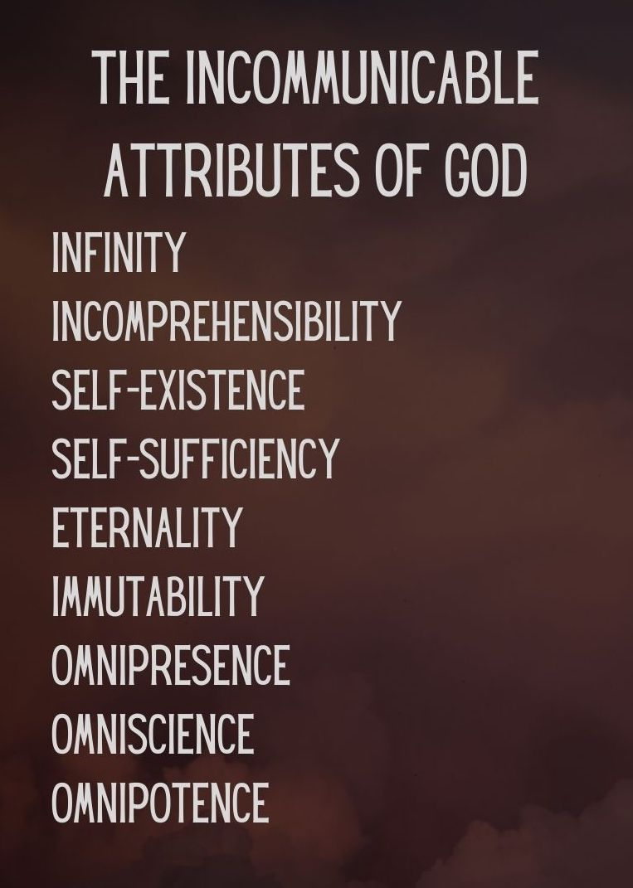
Key Truth/Principle
‘What comes into our minds when we think about God is the most important thing about us.. Were we to extract from any man a complete answer to the question, 'What comes into your mind when you think about God?' we might predict with certainty the spiritual future of that man (AW Tozer)

Key Verse(s)
Psalm 139:1-4 / Heb 4:13, 15-16 / Prov 9:10 / Ex 20:20

Key Point(s)
- God is OMNISCIENT (all-knowing)

GROUP HINTS
- WORSHIP: Deliberately choose songs (if you’re singing/listening – there are other ways to do worship!) that are ABOUT GOD, and WHO HE IS. You may want to use the song sung on Sunday if they are helpful.
- COMMUNION: Communion would be a great way to finish things (or during) as it focuses us on the WEIGHT & WONDER of God! Hebrews 12 can be a great weekly passage to dip into
- WORD: Start by reading these scriptures and getting everyone to STOP and BE STILL, and think about God as the verses are read (closing eyes might help). Encourage everyone to ‘gather their scattered senses’ to think on God.

KEY QUESTIONS

- What comes to your mind when you think about God knowing all things?

- Read Psalm 139:1-4 David describes how perfectly/fully God knows him. His thoughts, his ways, his words.
  - There’s nothing hidden from God (Heb 4:13, Psalm 139:11)
  - How do you feel knowing that God knows everything about you? Even your thoughts?

3) The fear of the Lord brings wisdom and may guard us from sin, Read Prov 9:10, Ex 20:20. How do you feel about God knowing the secrets of your heart?
4) Psalm 51- confession and Godly grief: God knows everything- including the worst of you and me. Is that a source of fear, comfort, both? In what ways do you try to hide from God?

5) Heb 4:15-16. When you sin, do you draw near to Jesus with confidence? Why/why not?

6) How can you enjoy the wonder of God’s omniscience this week?

How can you practically, think about God more regularly?
  - Routine: Meal times, wake up, going to bed? (e.g. a verse when you wake up to fix your thoughts, kneeling when going to bed, prayer and pause at meal times)
  - Scripture memory: Weekly/situation al verses (e.g. at work if tough verses on God being sovereign. In suffering verses on trusting God..)
  - Group texts: scriptures/truths/reminders (possibly delegating each week to someone to stir thoughts, or a day to each member)

Questions from Wilkin, Jen. None Like Him (p. 29). Crossway. Kindle Edition.

