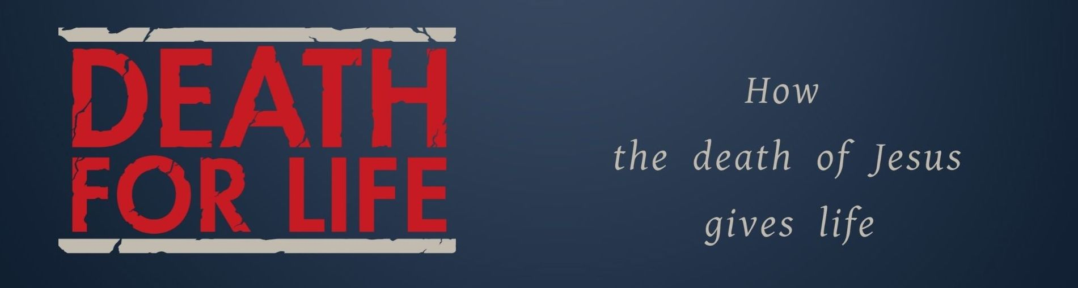
Key Truth/Principle: Jesus is my Ransom

Key Verse(s): Matthew 20:28; 1 Peter 1:18-19; 1 Corinthians 6:20, Revelation 5:9

Suggested format: Social time/ice-breaker, Word, worship with communion and prayer

Key Point(s)
- Christ came to die
- We are a bought people
- The sobering of sin and wonder of grace

** TOP TIPS **
Remember people are indwelt with the spirit – expect them to have something to bring – most just need permission and clarity, and yearn for depth.

- WELCOME: Have fun, involve everyone, keep it moving
- WORSHIP: Deliberately LEAD people into stepping out – most people appreciate specific guidance and feel released to know how to participate (e.g. let’s read a Psalm together and use the words to help us worship, let’s listen to this song, let’s sing now, let’s have a time of prophecy and hearing from God, if you feel you want to start a song please do). Encourage gifts!
- PRAYER: Weave into all you do, respond to things as they come up and help people by being specific (e.g. let’s all go round and pray shorts prayers thanking God for a particular characteristic
- WORD: Some folks would not have been there on Sunday – don’t; worry too much about recapping, just dive into questions. Splitting people into pairs/small groups with specific question and a time frame usually brings out the best discussion and involvement of everyone.

KEY QUESTIONS
1. What struck you on Sunday?
2. What comes to mind when you think of Jesus as being your RANSOM?
3. Have your reconciled that you are not your own? How does this make you feel? In what ways do you find yourself ‘holding on to your rights?’
communion!

