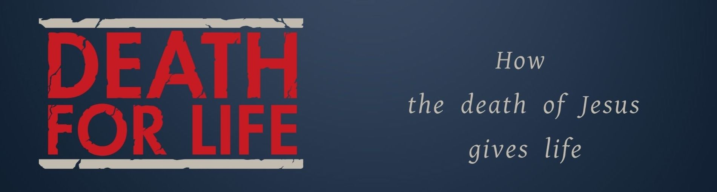
Key Truth/Principle
Jesus is my Righteousness

Key Verse(s)

Key Point(s)
- What is righteousness>?
- Why do we need it?
- How do we obtain it?

KEY QUESTIONS

1. What does righteousness mean to you?

2. How are some ways that as Christians we can end up living in ways that are self righteous?

3. What does it mean that we have been given Gods gift of righteousness?

