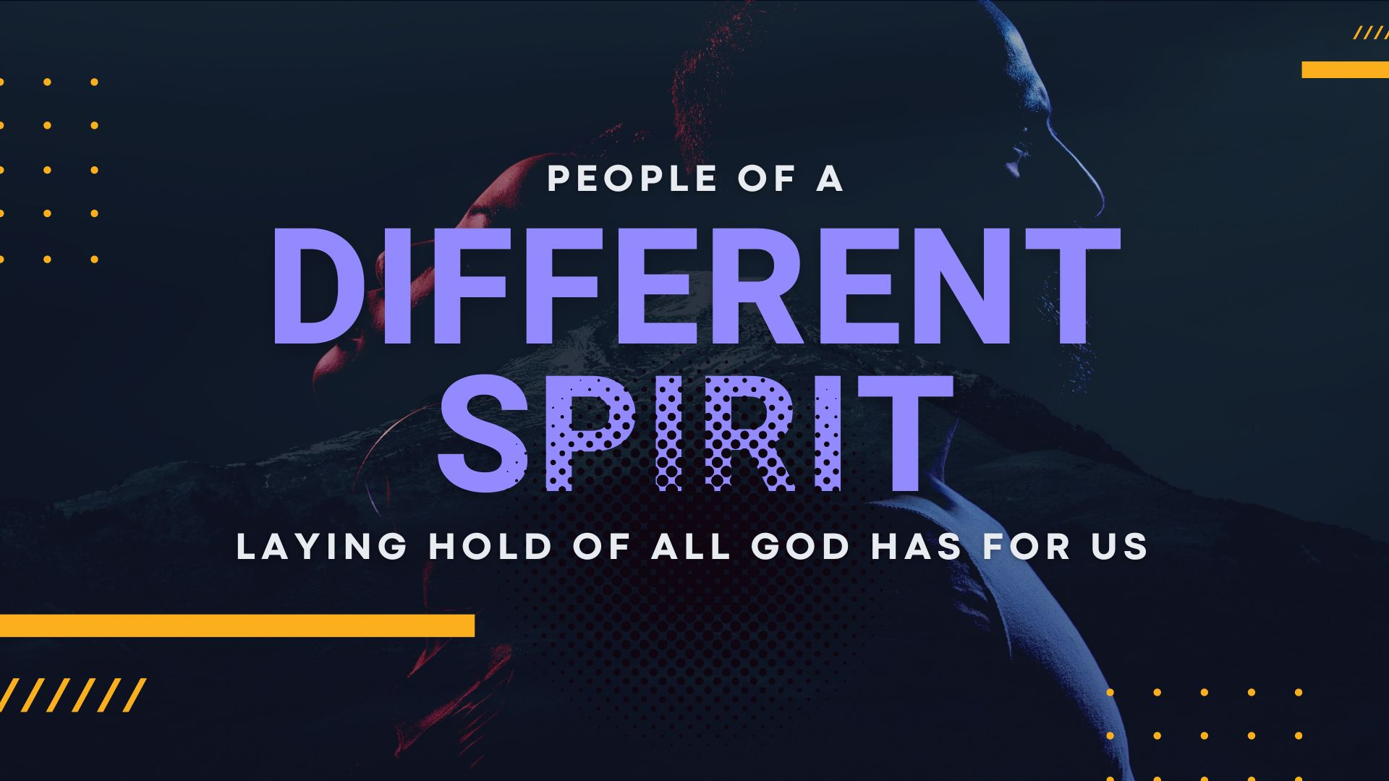
Key Truth/Principle: People of a different Spirit are PROMISE SHAPED and therefore have a different PERSPECTIVE

Key Verse(s): Numbers 13

Suggested format: Social time/ice-breaker, Word, worship with communion and prayer

Key Point(s)
- What is shaping your perspective?
- What promises are you holding fast to that shape your perspective?
- What do you need to throw off that is hindering you laying hold of what God has for you?

** TOP TIPS **
Remember people are indwelt with the spirit – expect them to have something to bring – most just need permission and clarity, and yearn for depth.

- WELCOME: Have fun, involve everyone, keep it moving
- WORSHIP: Deliberately LEAD people into stepping out – most people appreciate specific guidance and feel released to know how to participate (e.g. let’s read a Psalm together and use the words to help us worship, let’s listen to this song, let’s sing now, let’s have a time of prophecy and hearing from God, if you feel you want to start a song please do). Encourage gifts!
- PRAYER: Weave into all you do, respond to things as they come up and help people by being specific (e.g. let’s all go round and pray shorts prayers thanking God for a particular characteristic
- WORD: Some folks would not have been there on Sunday – don’t; worry too much about recapping, just dive into questions. Splitting people into pairs/small groups with specific question and a time frame usually brings out the best discussion and involvement of everyone.

KEY QUESTIONS
1. What struck you about the sermon?
- Open-ended question that might lead into some of the others
2. How do the promises of God in scripture shape you?
- What does that look like?
- How do you lay hold’ of these truths? E.g. prayer, memorization, stepping out
3. Do you carry any specific promises from God/prophetic words that have/are shaping you
4. What do you need to throw off that is hindering you laying hold of what God has for you?

