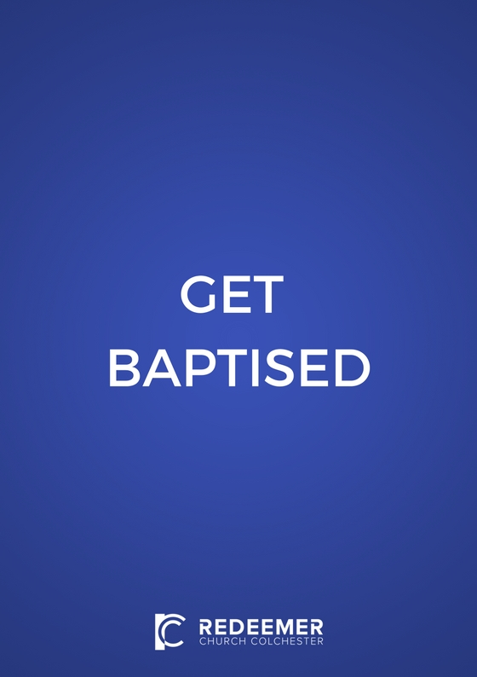

CONTENTS

Chapter 1

Chapter 2

Chapter 3

Chapter 4

Chapter 5

Chapter 6
What is water baptism? 2

Why should we be water baptised? 3

How should water baptism happen? 4

What does water baptism achieve? 5

What if I was water baptised as a baby? 6

A final checklist and common questions 8

This booklet is slightly adapted from PJ Smyth’s own ‘Get Baptised’

CHAPTER 1
WHAT IS WATER BAPTISM?

Our word “baptism” comes from the Greek word “baptizo”. It is one of the few words in our English bibles that has never been translated properly into an English word, but has been left in its original form. This hasn’t always helped people to understand what baptism actually is. It is important that we understand what baptism really is, and allow it to be something that brings life and grace to us rather than simply being a strange religious rite, empty of real meaning.

Two positions on water baptism that we would not be comfortable with include:

A. Baptism conveys grace to the person being baptised without requiring any demonstration of faith from them. This is why children are baptised. It is understood that baptising children brings them into the church and so somehow into salvation.

B. ‘Christening’ the children of believing parents is understood as a sign of covenant – the New Testament equivalent of circumcision. Unlike in Catholicism it is not believed that this baptism earns salvation, so there needs to be a later response of faith by the individual, which is recognised when they are confirmed.

The problems with these positions:
1. According to the bible, baptism doesn’t save anyone. Rather it is the outward sign of internal salvation.
2. According to the bible, baptism should follow not precede salvation.

Therefore, in contrast to these expressions of baptism, we believe that the biblical basis for baptism is that baptism is only for those who have already responded in faith to Jesus. Baptism does not save us, but it is a powerful sign and declaration of saving faith.

CHAPTER 2
WHY SHOULD WE BE WATER BAPTISED?

- Because Jesus was baptised (Mt 3v16).

- Because Jesus told us to be baptised (Mt 28v19).

If these were the only two reasons that the bible gave us to be baptised, then surely this would be enough reason to get baptised – after all, Christians are by definition those who imitate Jesus (1 Jn 2v6) and obey Jesus (Jn 14v15)!

- The disciples baptised people (Jn 4v1).

- Peter said we should be baptised (Acts 2v38).

- Peter and John expected that all new believers would be baptised (Acts 8v16).

- Philip endorsed it by baptising the Ethiopian (Acts 8v38).

- Paul himself was baptised (Acts 9v18).

- Paul expected that all believers had been baptised…and he made sure just in case they were not (Acts 19v1-5).

- Paul often references baptism in his theological writings. Clearly water baptism was a huge deal for Paul, and his assumption was that all believers had been water baptised (Rms 6v3; 1 Cor 1v13-17; 1 Cor 10v2; 1 Cor 12v13; 1 Cor 15v29; Gal 3v27).

- Peter also references baptism in his theological writings (1 Pet 3v20).

CHAPTER 3
HOW SHOULD WATER BAPTISM HAPPEN?

1. With lots of water!
The Greek word baptizo means, ‘to plunge, dip, immerse’. There is an expectation in the word itself that the person being baptised is completely immersed in water. In the New Testament accounts of baptism we can see that it always seemed to happen where there was lots of water, normally in a river. The person getting baptised was not sprinkled but was baptised – plunged, dipped, immersed. This was not because there is some magic about the amount of water used, but because of what the water symbolises. Water baptism represents our joining with Jesus in his burial and resurrection - a symbolism which sprinkling misses entirely. Take a look at Paul’s brief description of baptism in Romans 6v3-4, and try to imagine a polite little sprinkling of water:
Do you not know that all of us who have been baptised into Christ Jesus were baptised into his death?We were buried therefore with him by baptism into death, in order that, just as Christ was raised from the dead by the glory of the Father, we too might walk in newness of life (Rms 6v3-4).

2. With lots of people watching – none of this secret business!
Most of the biblical accounts of baptism occur in public places. Think of the masses getting baptised in the Jordan River like Jesus did, and thousands of new believers in Acts 2. Furthermore, as baptism is a public declaration of your faith in Jesus, then you will want to do it with a variety of believers and unbelievers watching. Most people find that the best way is to be baptised during a Sunday meeting…but be sure to make it a ‘guest service’ to ensure that there are the maximum possible number of unbelievers present.

3. Who actually does the baptising?
Church leaders (elders, pastors or Life Group leaders) are the ones who normally carry out baptisms, although it is often nice for believing friends or family to be part of the action. It is also great for the believer who ‘won you to Christ’ to be involved, rather like Philip was with his Ethiopian convert.

CHAPTER 4
WHAT DOES WATER BAPTISM ACHIEVE?

Remember, baptism is not necessary for salvation…
We see this in the account of the thief who was crucified next to Jesus but before he died put his faith in Jesus. Clearly, the thief was not baptised, but Jesus said to him, Today you will be with me in paradise (Luke 23v43). However, this exceptional case should not make us think that baptism is somehow optional for Christians…

But baptism is an essential aspect of salvation…
We need to understand that it is part of the normal order of salvation and without baptism we are missing out on an important part of God’s grace to us. As baptism is a command of Jesus, it is necessary if we are to be obedient to him. Jesus instructed his disciples, ‘Go and make disciples of all nations, baptising them in the name of the Father and of the Son and of the Holy Spirit’ (Matthew 28v19).

What are the direct benefits to me of being baptised?

1. The pleasure of knowing that I have imitated and obeyed Jesus.

2. Courage and boldness: many people testify that once they ‘nailed their colours to the mast’ through public baptism, they experienced a new courage and boldness in living for Jesus. Baptism strengthens and encourages our faith.

3. Encouragement for believers: it is a great source of joy and strength for fellow believers who watch you being baptised – it is visible proof of the advance of God’s kingdom.

4. Testimony to unbelievers: baptism is a powerful visual picture to unbelievers of the gospel. Make sure you bring your friends and family along!

CHAPTER 5
WHAT IF I WAS WATER BAPTISED AS A BABY?

If you were ‘baptised’ as a baby, I would say that you should be baptised now as a believer. This is because your infant baptism preceded you becoming a believer, so it actually doesn’t even class as a baptism, at least not according to the bible.

Usually there are historical and emotional reasons why people who have been baptized as babies do not want to entertain the thought that they were actually doing something that wasn’t biblical. Often well-meaning parents baptised their children out of either (a) obedience to the traditions of their church but without properly checking the scriptures, or (b) to clear their conscience that this ritual will somehow assist their children in their salvation.

However, there just doesn’t seem to be any biblical evidence to support getting baptised before you actually believe. On the contrary, the bible is clear that baptism should follow repentance. Look at the following scriptures that show baptism and repentance to be irrevocably linked – there is no kind of baptism in the bible that isn’t a direct response to repentance/believing. The bible knows nothing of baptism that happens many years before the person makes a commitment to Christ for themselves.

Confessing their sins, they were baptized by him in the Jordan River. (Mt 3v6)

And so John came, baptizing in the desert region and preaching a baptism of repentance for the forgiveness of sins. The whole Judean countryside and all the people of Jerusalem went out to him. Confessing their sins, they were baptized by him in the Jordan River. (Mk 1v4-5)

Whoever believes and is baptized will be saved, but whoever does not believe will be condemned. (Mk 16v16)

Peter replied, "Repent and be baptized, every one of you, in the name of Jesus for the forgiveness of your sins. (Acts 2v38)

But when they believed Philip as he preached the good news of the kingdom of God and the name of Jesus Christ, they were baptized, both men and women. Simon himself believed and was baptized. (Acts 8v12)

(Paul was saved on the Damascus road) Then Ananias went to the house and entered it. Placing his hands on Saul, he said, "Brother Saul, the Lord Jesus, who appeared to you on the road as you were coming here has sent me so that you may see again and be filled with the Holy Spirit." Immediately, something like scales fell from Saul's eyes, and he could see again. He got up and was baptized. (Acts 9v17)

Before the coming of Jesus, John preached repentance and baptism to all the people of Israel (Acts 13v24)

The Lord opened her heart to respond to Paul's message (must mean believe/repent). When she and the members of her household were baptized, she invited us to her home. (Acts 16v15)

They replied, "Believe in the Lord Jesus, and you will be saved - you and your household." Then they spoke the word of the Lord to him and to all the others in his house. At that hour of the night the jailer took them and washed their wounds; then immediately he and all his family were baptized. The jailer brought them into his house and set a meal before them; he was filled with joy because he had come to believe in God--he and his whole family. (Acts 16v31-33)

Crispus, the synagogue ruler, and his entire household believed in the Lord; and many of the Corinthians who heard him believed and were baptized. (Acts 18v8)

So Paul asked, "Then what baptism did you receive?" "John's baptism," they replied. Paul said, "John's baptism was a baptism of repentance. He told the people to believe in the one coming after him, that is, in Jesus." (Acts 19v3)

CHAPTER 6
A FINAL CHECKLIST AND COMMON QUESTIONS

Checklist
• Because baptism should always follow salvation and not precede it, am I sure that I am born again?
• Have I gone through the GET BAPTISED booklet, and I am feeling 100% convinced from the bible of my need to be baptised?

On the Day
• Show up early and check in with the leader
• Wear non-see-through-when-wet clothing (T-shirt and shorts) • Bring a towel
• Bring loads of unsaved family and friends…have a ‘tea’ afterwards with them – really make a moment of it!

Common Questions
• What if my parents are not happy about me getting baptised? Then it is usually best to leave the matter until you have the freedom to make these decisions for yourself. Chat to your pastor about it.

• What if I was baptised as a baby? The bible actually teaches that water baptism should follow repentance, not precede it (Acts 2v38 and Mark 16v16). Furthermore, infant baptism is unhelpful because people usually assume that this means that they are automatically saved. So, if you were ‘baptised’ as a baby, we suggest that you now get baptised as a believing adult.

• Must I get baptised again if I join your church? No. Baptism was never intended as a sign of joining a local church.

• What if my previous baptism was not meaningful for me? Chat to your pastor about it, but it is usually best to get baptised again in a way that is meaningful for you.

