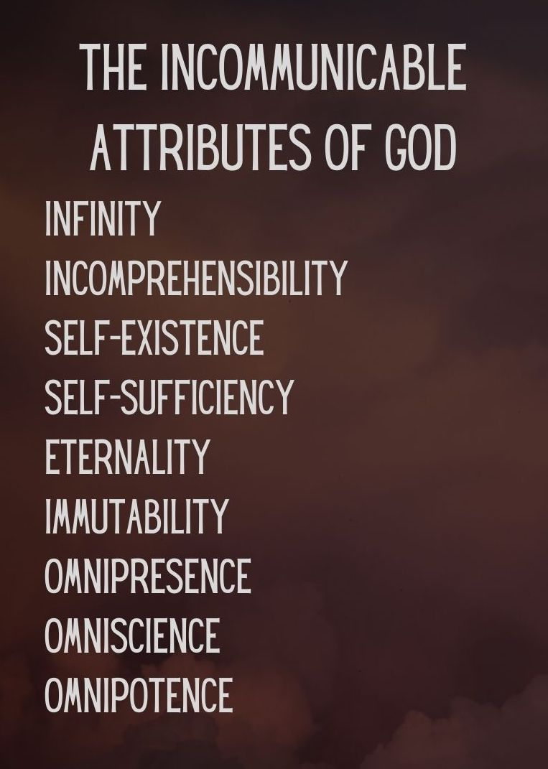
Key Truth/Principle
‘What comes into our minds when we think about God is the most important thing about us.. Were we to extract from any man a complete answer to the question, 'What comes into your mind when you think about God?' we might predict with certainty the spiritual future of that man (AW Tozer)

Key Verse(s)
Psalm 90:2 / Job 11:7-9 / /Psalm 145:3 / 1 Kings 8:27 / Isa 40:12-13

Key Point(s)
- God is INFINTIE (The God of No Limits)

GROUP HINTS
- WORSHIP: Deliberately choose songs (if you’re singing/listening – there are other ways to do worship!) that are ABOUT GOD, and WHO HE IS. You may want to use the song sung on Sunday if they are helpful.
- COMMUNION: Communion would be a great way to finish things (or during) as it focuses us on the WEIGHT & WONDER of God! Hebrews 12 can be a great weekly passage to dip into
- WORD: Start by reading these scriptures and getting everyone to STOP and BE STILL, and think about God as the verses are read (closing eyes might help). Encourage everyone to ‘gather their scattered senses’ to think on God.

Job’s friend Zophar in Job 11:7-9 ESV ⁷ “Can you find out the deep things of God? Can you find out the limit of the Almighty? ⁸ It is higher than heaven - what can you do? Deeper than Sheol—what can you know? ⁹ Its measure is longer than the earth and broader than the sea.

﻿David praises the infinitude of God’s greatness: Psalm 145:3 ESV Great is the LORD, and greatly to be praised, and his greatness is unsearchable.

﻿Solomon, too, acknowledges the limitlessness of God: 1 Kings 8:27 ESV But will God indeed dwell on the earth? Behold, heaven and the highest heaven cannot contain you; how much less this house that I have built!

KEY QUESTIONS

- What is your emotional response to the knowledge that God cannot be measured?

- How have you attempted to “take the measure” of God? What limits have you placed (or wanted to place) on his character or will?

- What God-given limitation or boundary do you most want to rebel against? How is that boundary for your good? For God’s glory?

- How can you practically, think about God more regularly?
  - Routine: Meal times, wake up, going to bed? (e.g. a verse when you wake up to fix your thoughts, kneeling when going to bed, prayer and pause at meal times)
  - Scripture memory: Weekly/situation al verses (e.g. at work if tough verses on God being sovereign. In suffering verses on trusting God..)
  - Group texts: scriptures/truths/reminders (possibly delegating each week to someone to stir thoughts, or a day to each member)

Questions from Wilkin, Jen. None Like Him (p. 29). Crossway. Kindle Edition.

