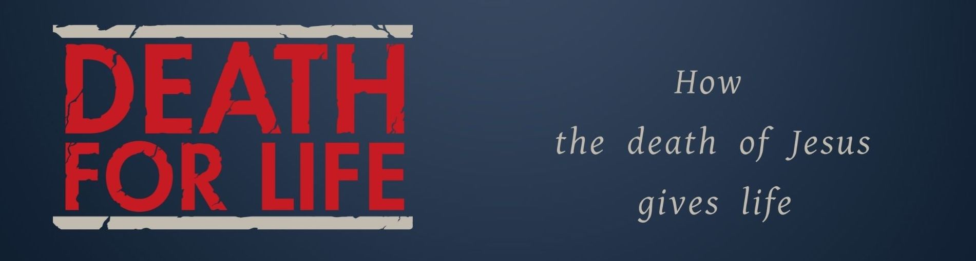
Key Truth/Principle
Jesus is my Redemption

Key Verse(s)
1 John 2:15,16; 2 Peter 2:19b; 1 Peter 1:18,19; Titus 2:13,14

Key Point(s)
- What is the Problem? The battle between ‘Loving the World’ v ‘Loving the Father’.
- What is the Solution? The redemptive work of Christ on the cross.
- How Should We Respond? Conviction, Confession, Repentance, Restitution & Reconciliation

KEY QUESTIONS

- How does the revelation that Jesus is our redemption impact you?

- What has Jesus redeemed us from? See Gal. 3:13; Col. 1:13-14; Rom. 6:6-12; Gal. 6:14-15.

- What has Jesus redeemed us to? See Psalm 49:15; Job 19:25; Rom. 8:23

