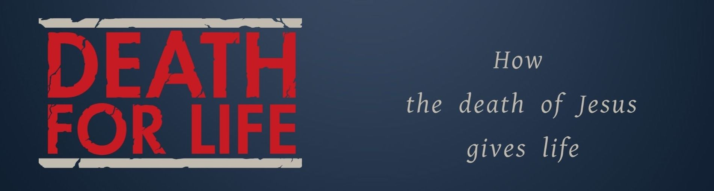
Key Truth/Principle
Jesus is my Cleanser – where I can find out what God is like

Key Verse(s)
1 John 1:9; Acts 22:16

Key Point(s)
- Sin DEFILES us
- Jesus CLEANSES us

KEY QUESTIONS
- I’d recommend breaking into smaller, single sex groups for more honesty and intimacy
- Leave significant time for prayer and worship – don’t; over talk and rehash. Smaller groups will foster intimacy and openness.

- How is this series impacting you?

- What things make people feel dirty?
  - E.g. rape, violence against…

- Have you ever meditating on the cleansing that Christ offers?
  - If not why not?
  - If so, what difference does it make?
  - The image of the ‘scapegoat’ might be helpful (Leviticus 16)

- What things are you carrying that you need to confess to Jesus, and ask others to help with?
- Give time for personal reflection and encourage follow up in individuals afterwards

