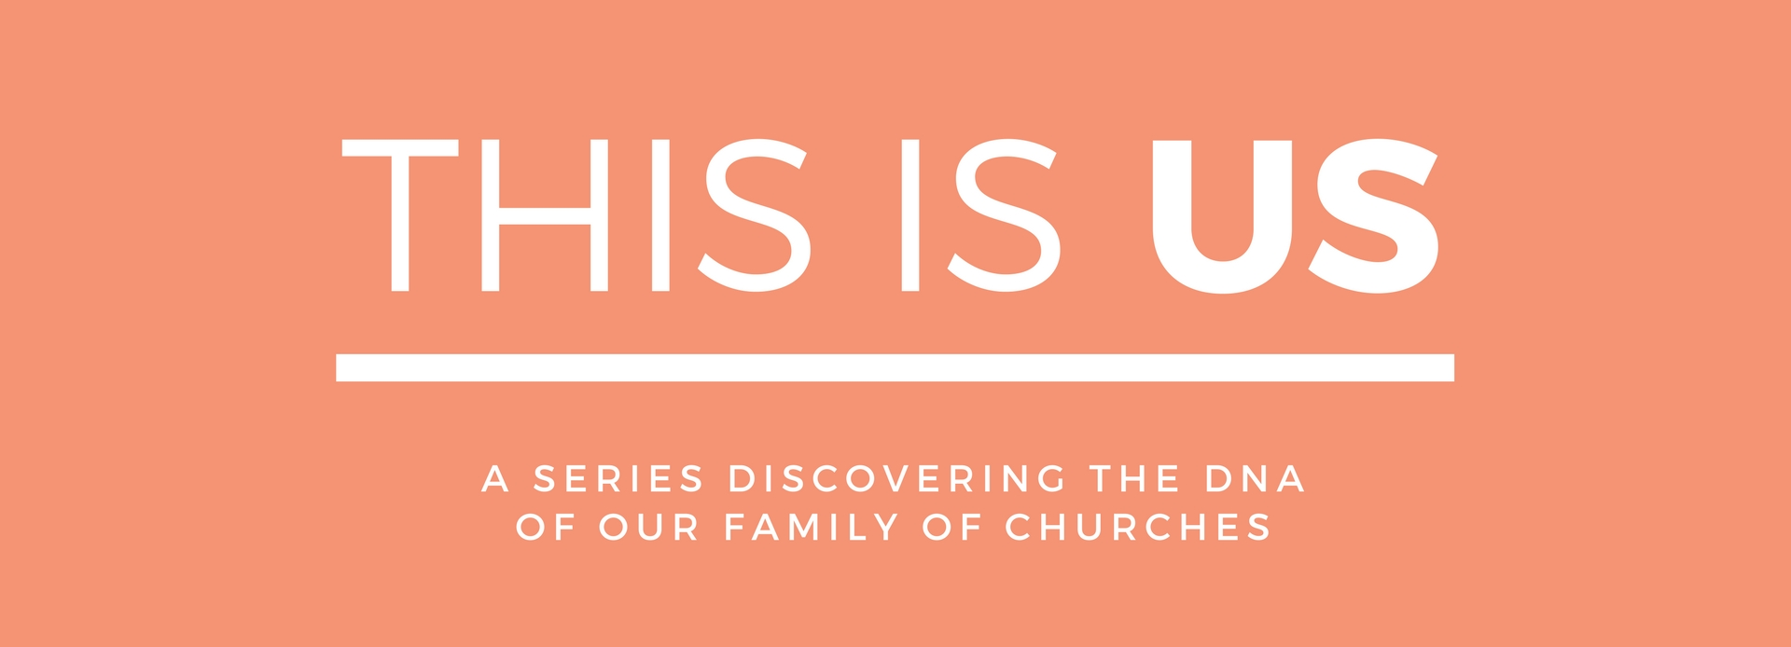

LIFE GROUPS – From Rows To Circles
Life Groups are our midweek groups that are smaller and more than our Sundays gatherings. On Sundays we sit in rows but in our small groups we sit in circles – getting to know each other better, building deeper friendships and sharing our lives. We gather in homes across Colchester and have lots of fun while learning and sharing about God, His Word and our lives and the mission we are on.

SERIES DESCRIPTION
Redeemer is part of a family of churches called ‘Relational Mission’ and consequently carries the same family ‘DNA.’ Mike Betts is the apostolic leader of Relational Mission, or you might say the ‘father of the family of churches’ and he has written a book highlighting the core DNA of Relational Mission and subsequently all the churches within the network/family. This ‘DNA’ gets expressed differently depending on various circumstances and how that is don is not prescriptive – each family has its own expression of this ‘culture’. This series unpacks what this DNA is and how we outwork it.

WEBSITE
You can read more about the series and catch up on sermons on our website. Go to redeemerchurchcolchester.org/thisisus.

THE BOOK
Mike Betts’ book ‘Relational Mission – A Way Of Life’ is available at church on Sundays or can be ordered from amazon here.

SERIES SCHEDULE
#1 23.04,17 A REAL FAMILY
#2 30.04.17 RAISING SONS & DAUGHTERS
#3 07.05.17 EVERYONE A WITNESS
#4 14.05.17 THE PRAYERS OF MANY
#5 21.05,17 CHURCH FOR A BROKEN WORLD
#6 28.05.17 STARTING NEW FAMILIES
#7 04.06.17 WE HAVE A COMPASS NOT A MAP
#8 11.06.17 GLOBAL SUNDAY ROAD-TRIP EXPERIENCE
#9 18.06.17 TOGETHER'17 FESTIVAL IMMERSION

THIS IS US LIFE GROUP NOTES
WEEK 1 – A REAL FAMILY
23.04.17

OVERVIEW
A REAL FAMILY – Being saved cannot be separated from being part of God’s family which is the church. This family is purposeful – a family on mission and that is what we are saved into. What does it mean to be part of God’s family and how can we be deliberate in growing towards our destiny?

SCRIPTURE
Galatians 4:4-7 ⁴ But when the fullness of time had come, God sent forth his Son, born of woman, born under the law, ⁵ to redeem those who were under the law, so that we might receive adoption as sons. ⁶ And because you are sons, God has sent the Spirit of his Son into our hearts, crying, “Abba! Father!” ⁷ So you are no longer a slave, but a son, and if a son, then an heir through God.

- Matthew 12:46 // Ephesians 2:19 // Ephesians 3:10 // Ephesians 4v 15-16
- Heb 10v25

MAIN POINTS
- YOU ARE SAVED TO BE PART OF GOD’S FAMILY
- YOU ARE SAVED TO BUILD UP GOD’S FAMILY
  - Meeting together deliberately
  - Everyone playing their part

QUESTIONS
- What struck you about the preach?
- How do you generally think of ‘church’?
  - As your family? Somewhere you attend? A place to praise?
  - How is this challenged by the sermon?
- How do you play your part in building up the church?
  - How can you grow in this area?
- What is your habit of ‘meeting together’ like?
  - What needs to change?
- What role do you have in church?
  - Where/How could you get involved?

